

R8428 G13 BIOS 调优设置指导

目录

R8428 G13 BIOS BMC调优设置指导 1

1. BIOS功能和设置 4

2. BIOS具体设置步骤 4

2.1. Mwaite/Monitor 4

2.2. CPU C6 report 5

2.3. Enhanced Halt State (C1E) 6

2.4. Package C State 7

2.5. EIST（P-State） 8

2.6. Hardware P-State 9

2.7. Turbo Mode 10

2.8. Power Performance Tuning 11

2.9. EIST 12

2.10. Power Policy Select 13

2.11. OS ACPI Cx 14

2.12. HT 15

2.13. VMX 16

2.14. MLC Streamer prefetcher 17

2.15. MLC Spatial prefetcher 17

2.16. DCU Streamer Prefetcher 18

2.17. DCU IP Prefetcher 19

2.18. NUMA Node 21

2.19. PCIe SR-IOV 21

2.20. Intel® VT for Directed I/O (VT-d) 23

2.21. Console Redirection 23

2.22. Console Redirection Settings 24

2.23. Boot 25

3. 运维操作 26

修订记录

|  |  |  |  |
| --- | --- | --- | --- |
| **日期** | **版本号** | **描述** | **更新人** |
| **2024-08-28** | V1.0 | 三快在线（美团）BIOS BMC设置指导 | 张天驰 |
|  |  |  |  |
|  |  |  |  |
|  |  |  |  |
|  |  |  |  |
|  |  |  |  |
|  |  |  |  |
|  |  |  |  |
|  |  |  |  |

*文件的版本号由“V×.×”组成，其中：*

*a）小数点前面的×为主版本号，取值范围为“0～9”。文件进行重大修订时主版本号递增1；*

*b） 小数点后面的×为次版本号，取值为“0～9，a～z”。文件每修改一次时次版本号递增1；主版本号发生改变时，次版本号重新置0；*

*c） 未批准发布的文件版本号为V0.×版，批准发布时为V1.0版。当主版本号发生改变时，前面只有次版本号不同的修订记录可以删除。*

# BIOS功能和设置

|  |  |
| --- | --- |
| **Configuration Item** | **Recommended Value** |
| Mwaite/Monitor | Disable |
| CPU C6 report | Disable |
| Enhanced Halt State (C1E) | Disable |
| Package C State | C0/C1 state |
| EIST（P-State） | Enabled |
| Hardware P-State | Native Mode |
| Turbo Mode | Enable |
| Power Performance Tuning | BIOS Control |
| EIST | Enable |
| Power Policy Select | Custom |
| OS ACPI Cx | ACPI C2 |
| HT | Enable |
| VMX | Enable |
| MLC Streamer prefetcher | Enable |
| MLC Spatial prefetcher | Enable |
| DCU Streamer Prefetcher | Enable |
| DCU IP Prefetcher | Enable |
| NUMA Node | Enable |
| PCIe SR- IOV | Enable |
| Intel® VT for Directed I/O (VT-d) | Enable |
| Console Redirection | Enable |
| Terminal typer | VT100 |
| Bits per second | 115200 |
| Data Bits | 8 |
| Parity | None |
| Stop Bits | 1 |
| Boot Type | Legacy |
| Quiet Boot | Enable |
| TME,TME-MT,TDX |  |

# BIOS具体设置步骤

## Mwaite/Monitor

按自检界面按DEL进入BIOS 设置界面

Socket Configuration->Advanced Power Management Configuration->CPU C State Control->Enable Monitor MWAIT--[Disable]

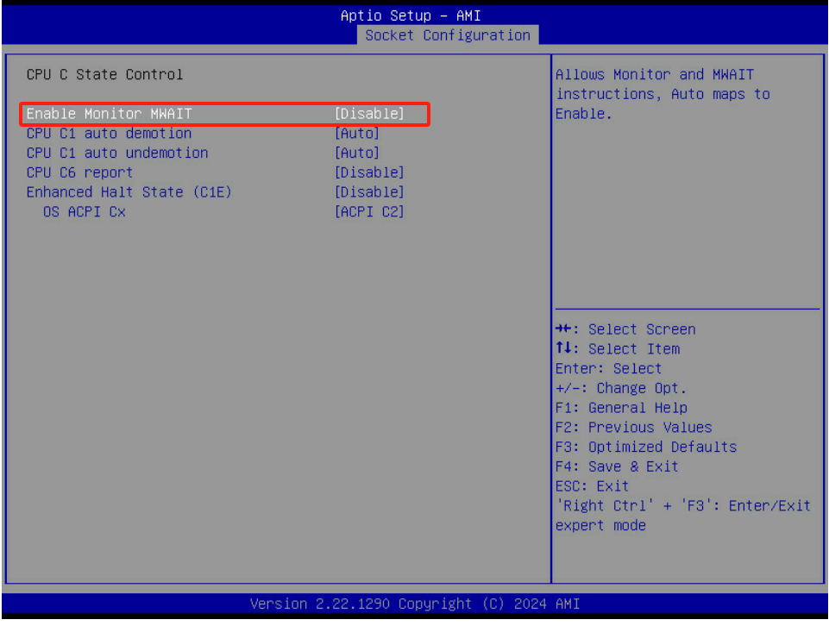

## CPU C6 report

Socket Configuration->Advanced Power Management Configuration->CPU C State Control->CPU C6 report--[Disable]

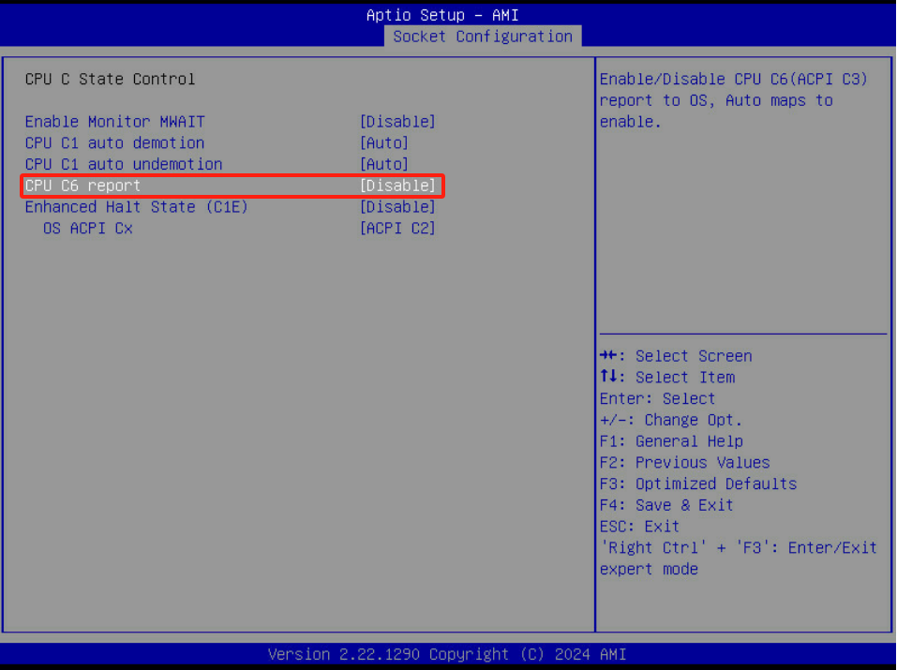

## Enhanced Halt State (C1E)

Socket Configuration->Advanced Power Management Configuration->CPU C State Control->Enhanced Halt State（C1E）--[Disable]

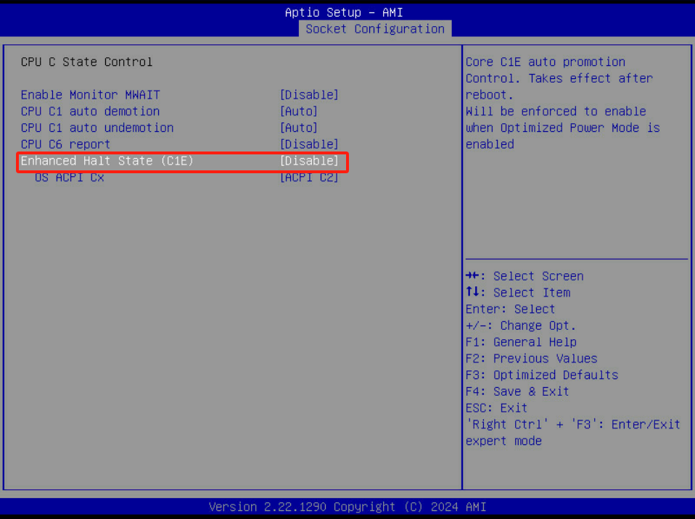

## Package C State

Socket Configuration->Advanced Power Management Configuration->Package C State Control--[C0/C1 state]

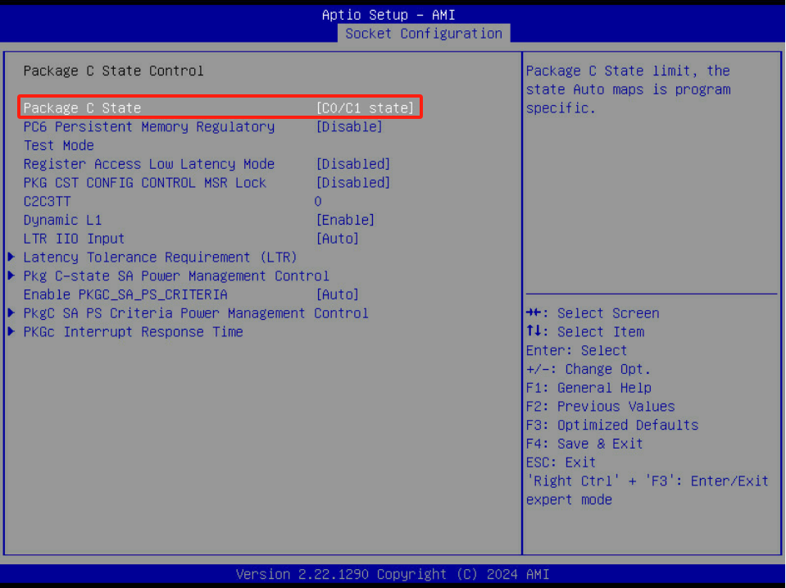

## EIST（P-State）

Socket Configuration->Advanced Power Management Configuration->CPU P State Control->SpeedStep（Pstates）--[Enable]

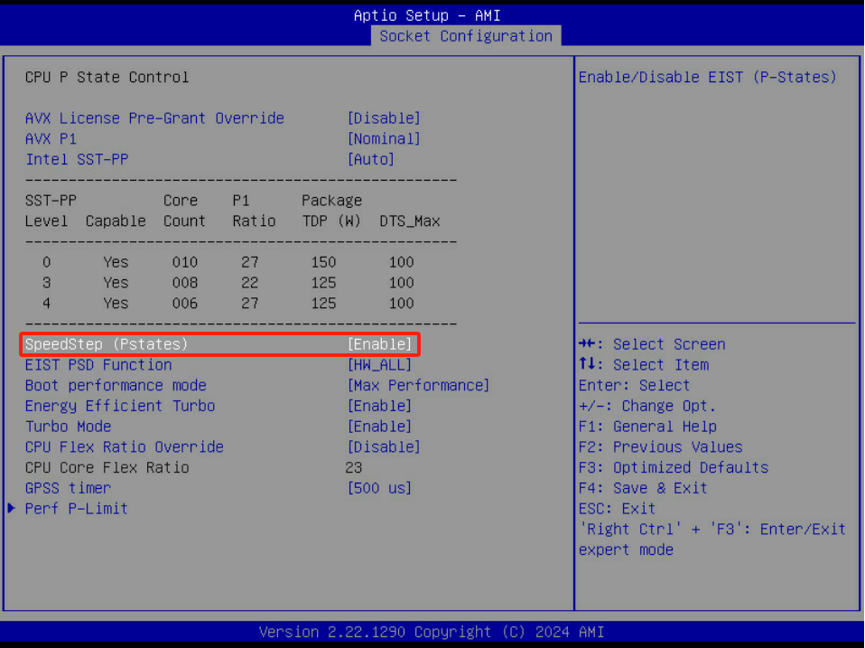

## Hardware P-State

Socket Configuration->Advanced Power Management Configuration->Hardware PM State Control->Hardware P-States--[Native Mode]

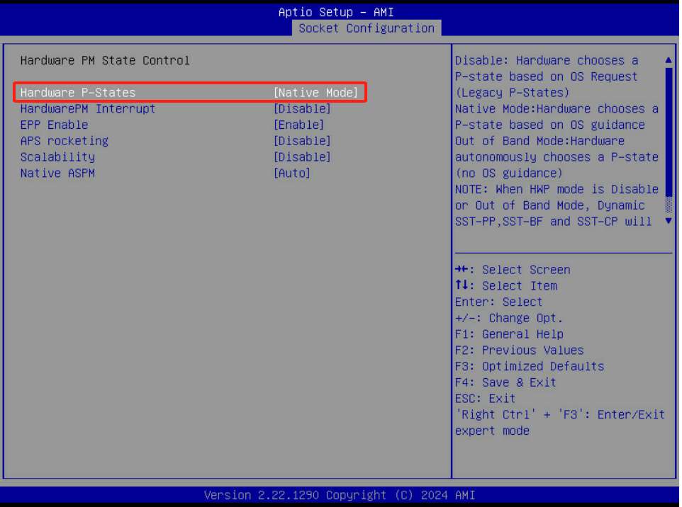

## Turbo Mode

Socket Configuration->Advanced Power Management Configuration->CPU P State Control->Turbo Mode--[Enable]

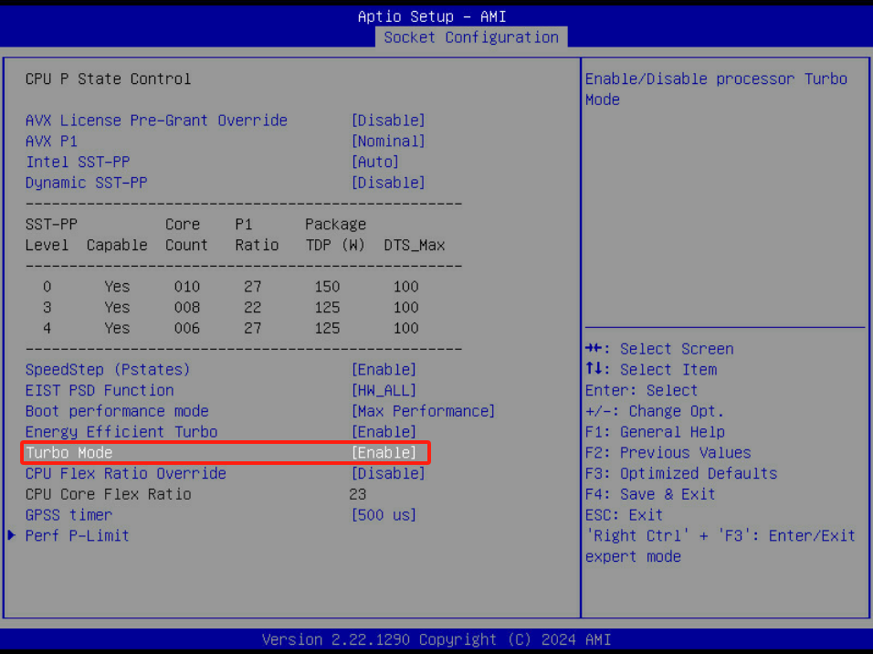

## Power Performance Tuning

Socket Configuration->Advanced Power Management Configuration->CPU - Advanced PM Tuning->

Energy Perf BIAS->Power Performance Turning--[BIOS Controls EPB]

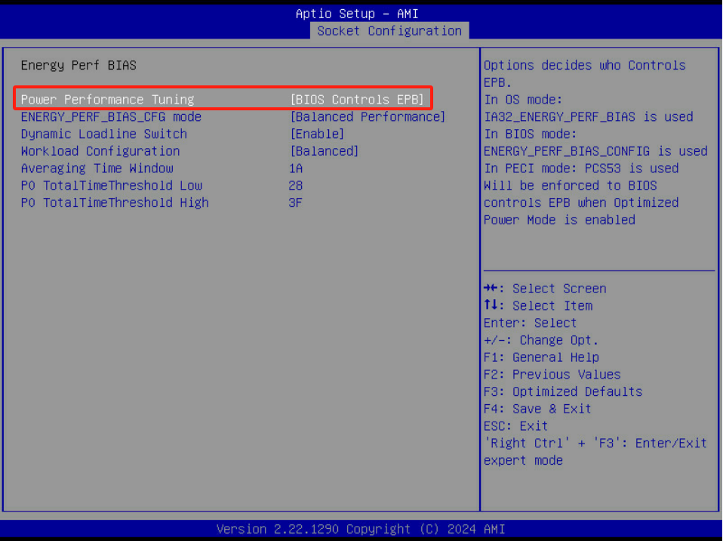

## EIST

Socket Configuration->Advanced Power Management Configuration->CPU P State Control->SpeedStep (Pstates)--[Enable]

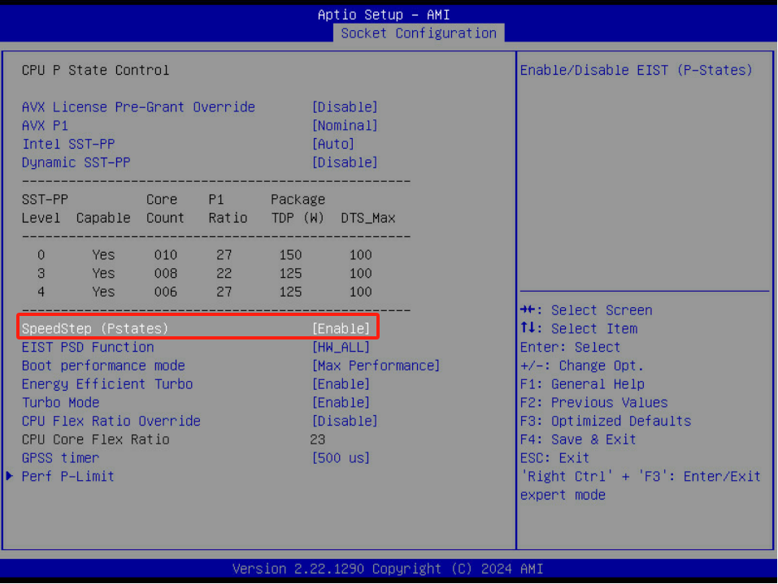

## Power Policy Select

Socket Configuration->Advanced Power Management Configuration->System Profile--[Custom]

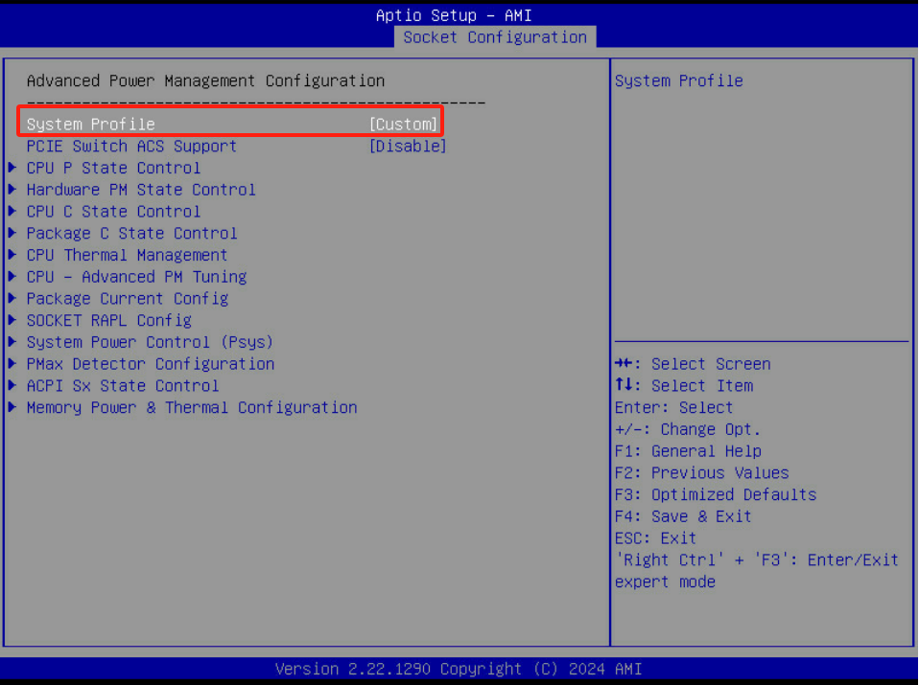

## OS ACPI Cx

Socket Configuration->Advanced Power Management Configuration->CPU C State Control->OS ACPI Cx--[ACPI C2]

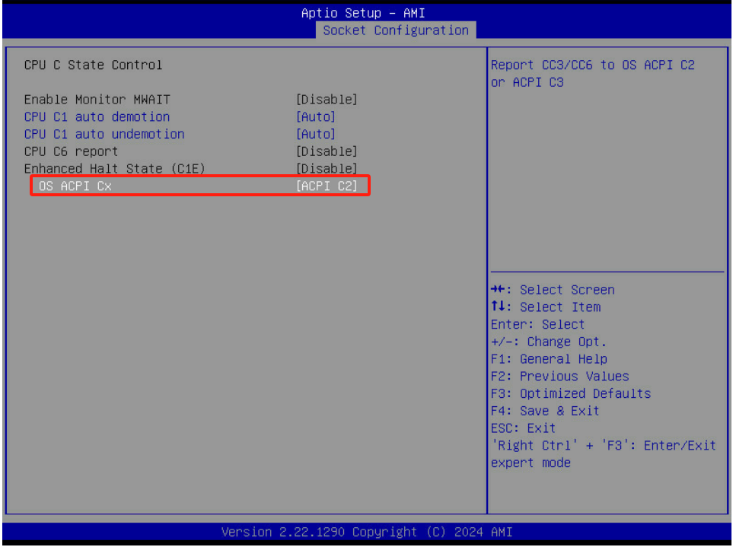

## HT

Socket Configuration->Processor Configuration->Enable LP[Global]--[ALL LPs]

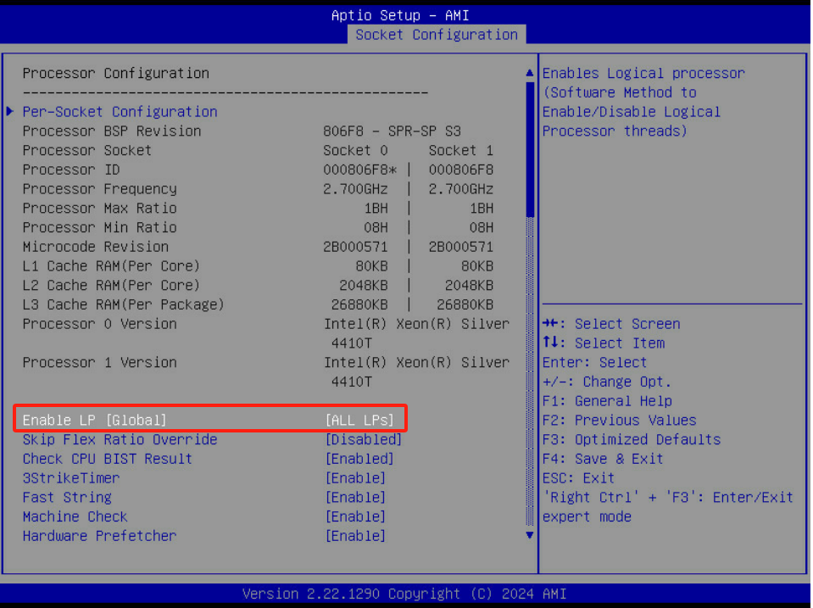

## VMX

Socket Configuration->Processor Configuration->VMX--[Enable]

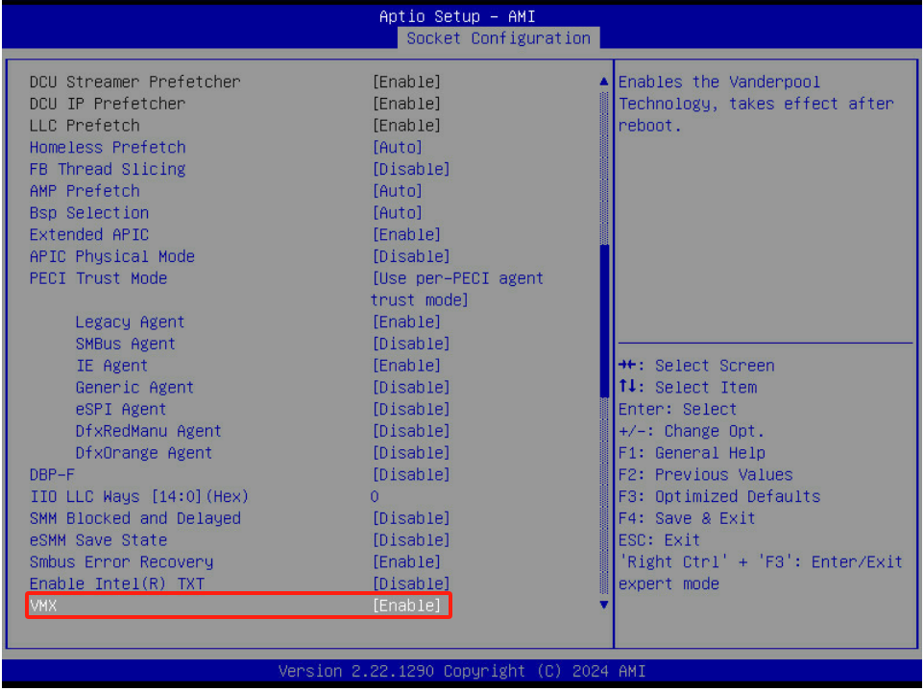

## MLC Streamer prefetcher

Socket Configuration->Processor Configuration->Hardware Prefetcher--[Enable]

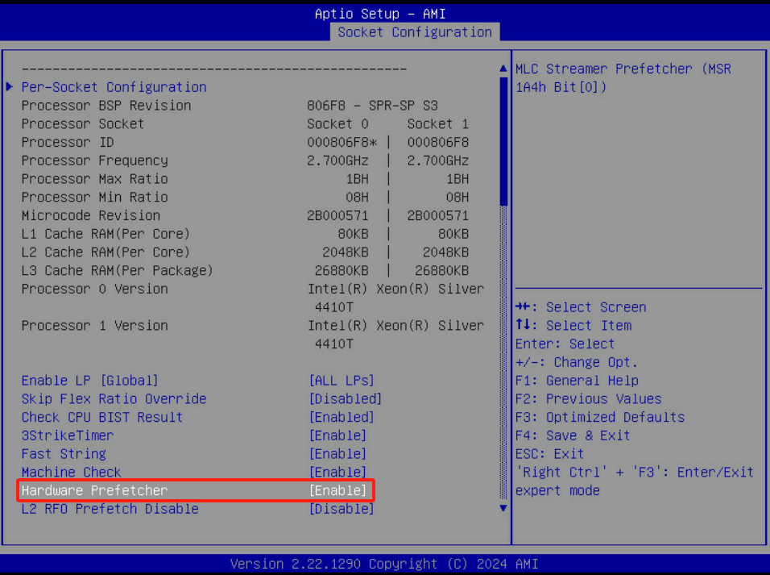

## MLC Spatial prefetcher

Socket Configuration->Processor Configuration->Adjacent Cache Prefetch--[Enable]

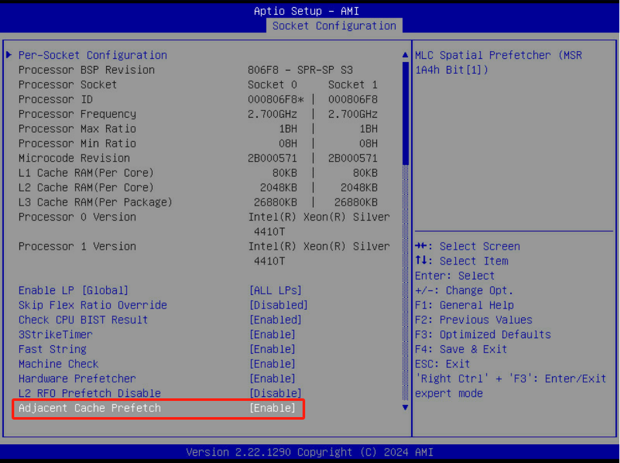

## DCU Streamer Prefetcher

Socket Configuration->Processor Configuration->DCU Streamer Prefetcher--[Enable]

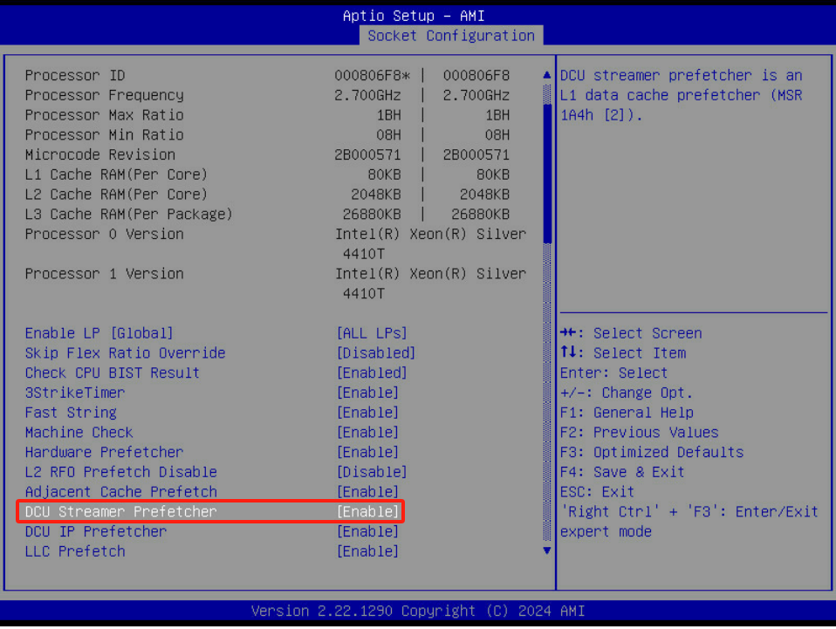

## DCU IP Prefetcher

Socket Configuration->Processor Configuration->DCU IP Prefetcher--[Enable]

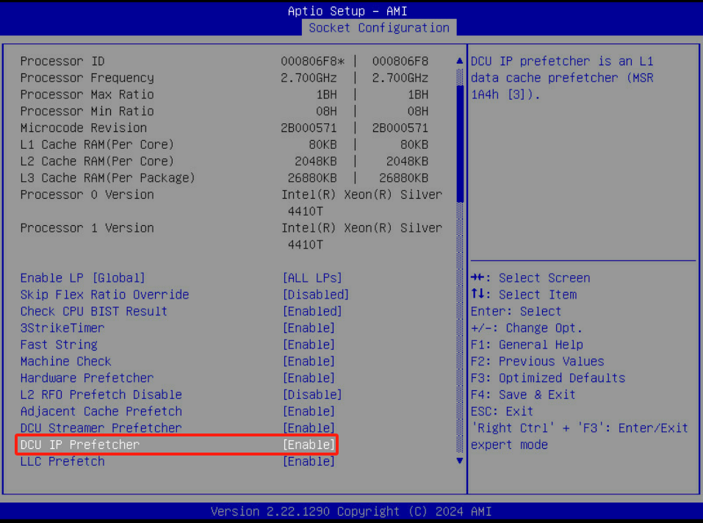

## NUMA Node

Socket Configuration->Common RefCode Configuration->Numa--[Enable]

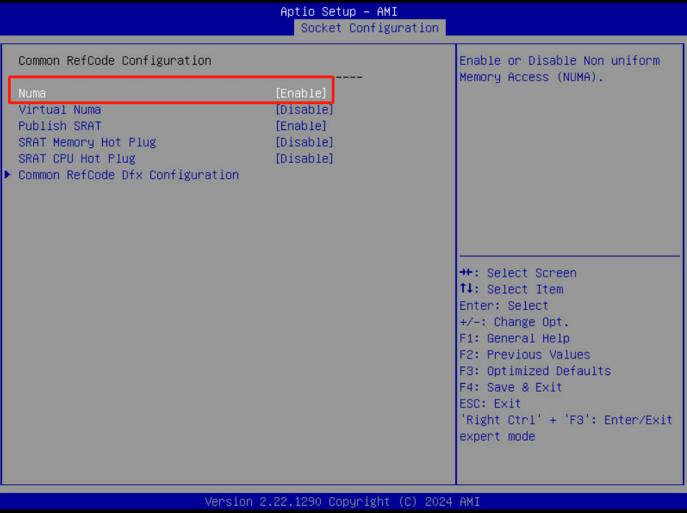

## PCIe SR-IOV

Advanced->PCI Subsystem Settings->SR-IOV Support--[Enable]

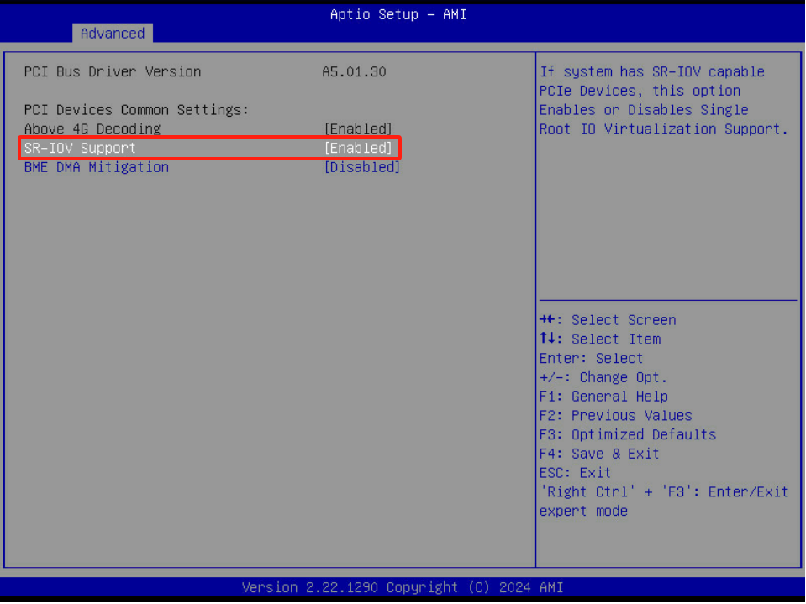

## Intel® VT for Directed I/O (VT-d)

Socket Configuration->IIO Configuration->Intel VT for Directed I/O（VT-d）->Intel VT for Directed I/O--[Enable]

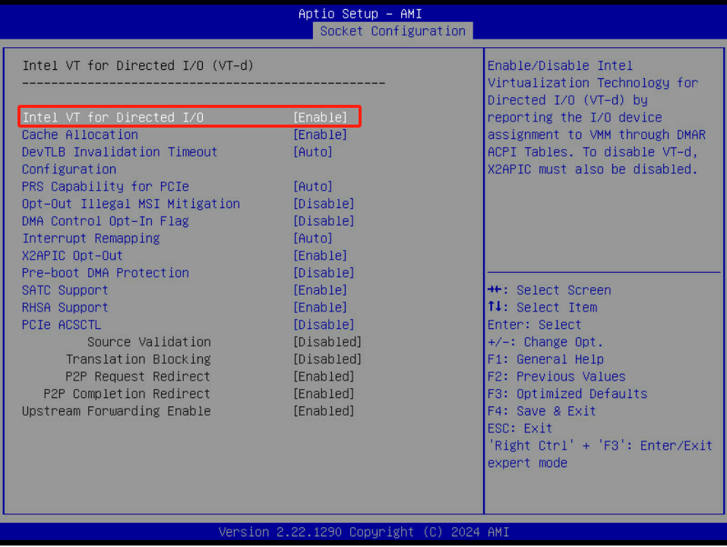

## Console Redirection

Advanced->Serial Port Console Redirection->COMO Console Redirection--[Enable]

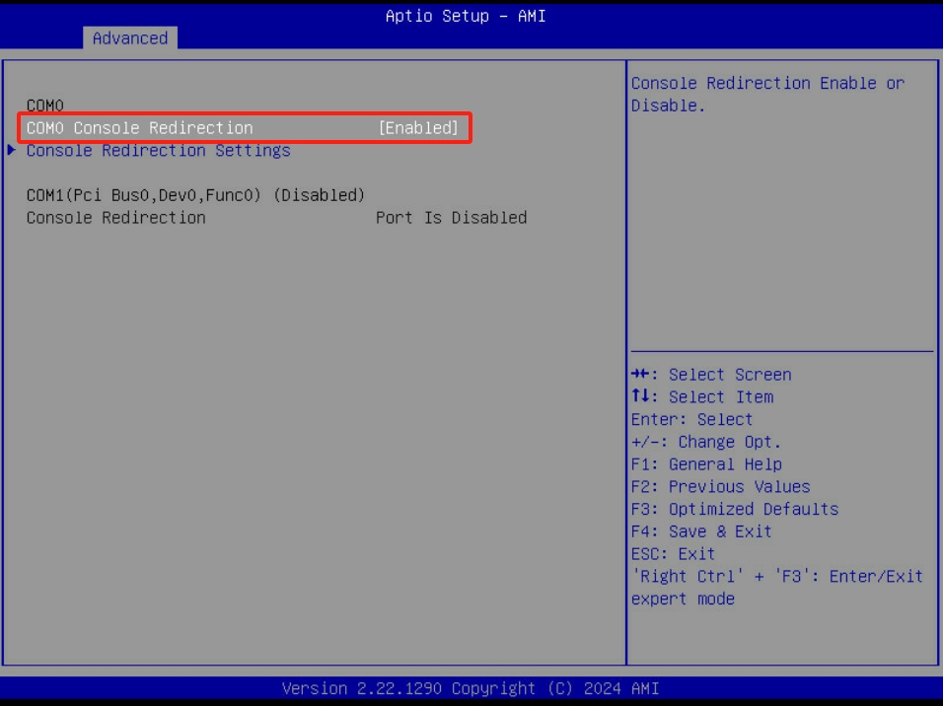

## Console Redirection Settings

Advanced->Serial Port Console Redirection->COMO Console Redirection Settings

|  |  |
| --- | --- |
| Terminal typer | VT100 |
| Bits per second | 115200 |
| Data Bits | 8 |
| Parity | None |
| Stop Bits | 1 |

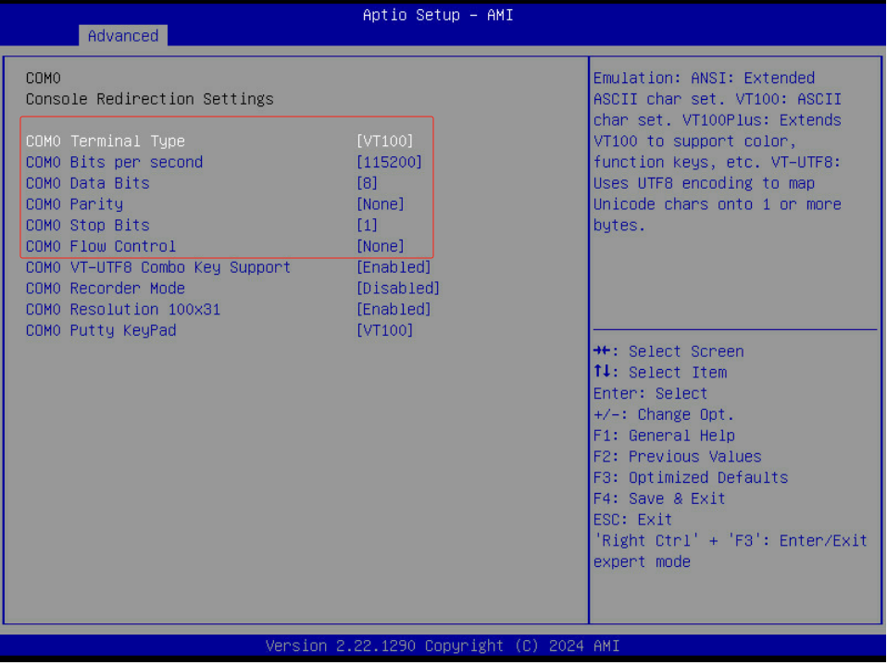

## Boot

Boot

|  |  |
| --- | --- |
| Boot Type | Legacy |
| Quiet Boot | Enabled |

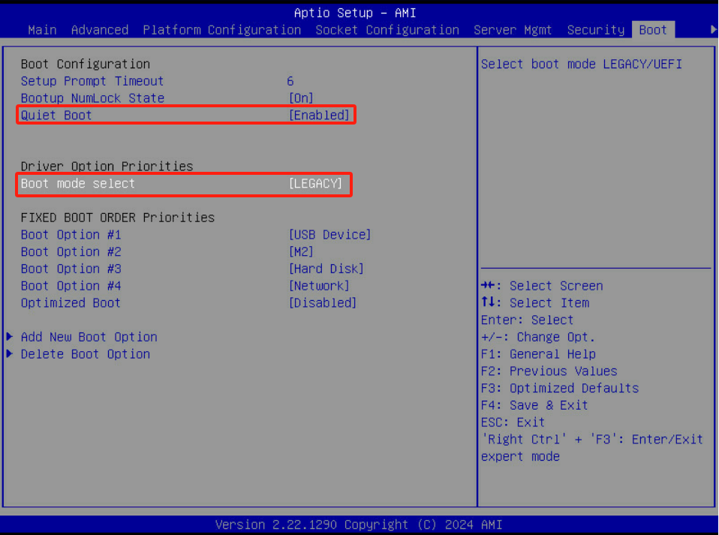

## TME,TME-MT,TDX

Socket Configuration---->Processor Configuration---->TME,TME-MT,TDX

